Number story question prompts- Parts of 17 (Please see the last Page for the picture)
Children are to answer the question verbally in full sentences and record as a part-part whole model (see answers below) Children may also wish to record their findings in a number sentence (i.e. 10 + 7 = 17)

- How many teachers are there altogether? This is our whole number.
Answer: “There are 17 teachers in total”

- How many are there of each teacher? How many pictures of Mrs Allen-Kelly? How many pictures of Miss Marsden? How many pictures of Miss Feldman?
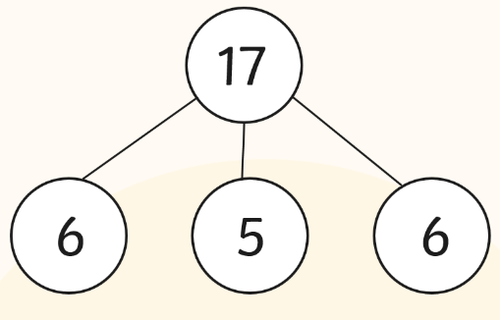
Answer: “There are 6 pictures of Mrs Allen-Kelly, there are 5 pictures of Miss Marsden, there are 6 pictures of Miss Feldman, altogether there are 17 teachers”
6 + 6 + 5 = 17

- How many teachers are there swimming in the sea? How many teachers are there para-gliding? How many teachers are there on the boat?
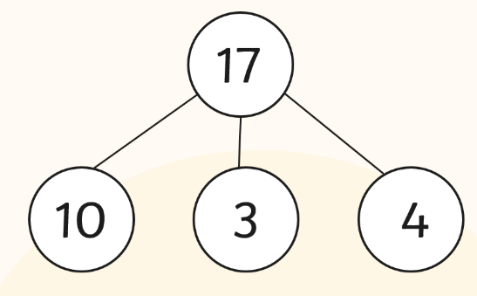
Answer: “There are 10 teachers swimming in the sea, there are 3 teachers para-gliding, there are 4 teachers on the boat, altogether there are 17 teachers”
10 + 3 + 4 = 17

- How many teachers are there wearing glasses? How many teachers are there not wearing glasses?
Answer: “There are 6 teachers wearing glasses, there are 11 teachers not wearing glasses, altogether there are 17 teachers”
6 + 11 = 17
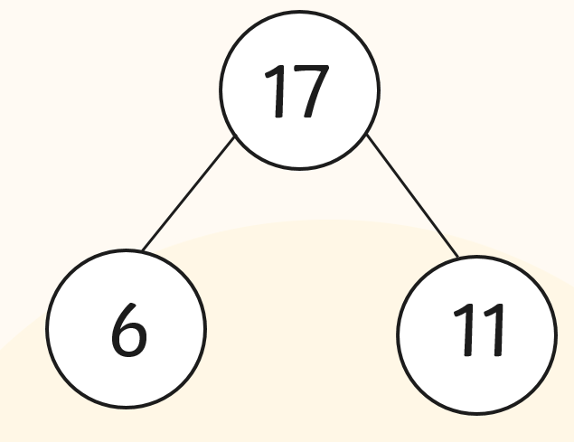

- How many teachers are there wearing hats? How many teachers are there not wearing hats?
Answer: “There are 5 teachers wearing hats, there are 12 teachers not wearing hats, altogether there are 17 teachers”
5 + 12 = 17
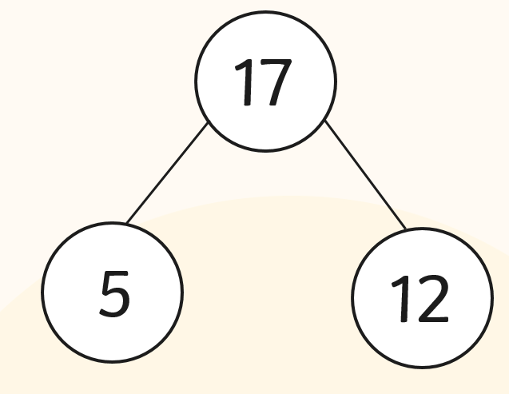

- How many teachers are there asleep? How many teachers are there awake?
Answer: “There are 2 teachers wearing asleep, there are 15 teachers awake, altogether there are 17 teachers”
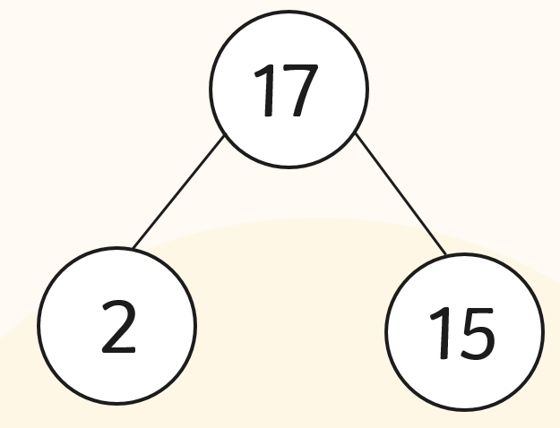
2 + 15 = 17

