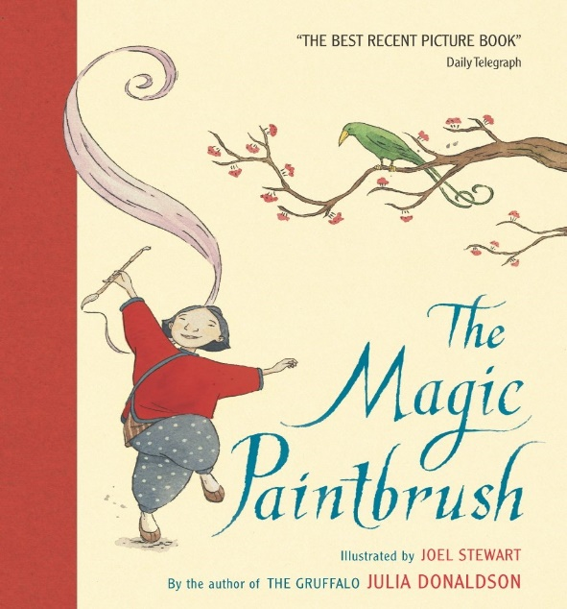
The Magic Paintbrush
by Julia Donaldson

Questions
- Read the following decodable words and choose which 4 words describe the main character, Shen:

strong selfish good bad artistic clever
- Why do you think Shen was asked only to paint for poor people and not for rich people? Do you think Shen and the villagers were rich or poor?
- How did Shen escape from prison?
- How did the villagers feel when Shen returned home with her magic brush?
- Did you notice something special about the sounds of the words in the story? (a: It is a rhyming story) Can you find an example of some rhyming words from the story.
- If you had a magic paintbrush that could make anything come to life, what would you draw? Perhaps you could also have a go at painting it at home.
Activities
- Have a look online or in a book to see if you can find China on a world map!
- You can access a range of activity ideas and colouring sheets based on The Magic Paintbrush at twinkl.co.uk:
https://www.twinkl.co.uk/search?term=the+magic+paintbrush
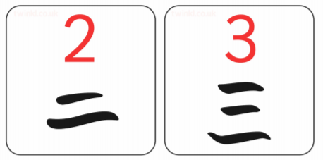
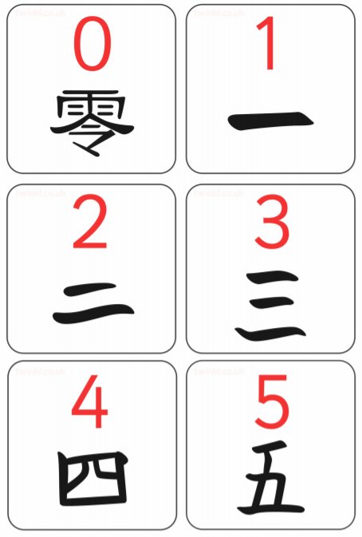
- You might like to have a go at writing numbers using Chinese (Mandarin) characters:
