|  |  |
| --- | --- |
|  | ../Google%20Drive/SLT/Headteacher/Administration%20Stuff/Logo/Logo%20for%20St%20James'/St%20James%20Logo%20Full%20Colour_grey%20type/Landscape/St%20James_landscape_full%20colou |
| **Autumn for all**  **a guide to school in September** | |
| **Date:** 01.09.20 | |

**Welcome back!**

**We’re really excited to finally be able to welcome back all our pupils to school – and to welcome some new faces, too, of course!**

We have lots of things in place to make sure our school continues to be a happy and healthy **and safe** place to learn.

We’ve closely considered lots of different aspects to make sure

the new school year goes smoothly.

**Autumn’s for all!**

Welcome back to all children on Monday 07 September 2020.

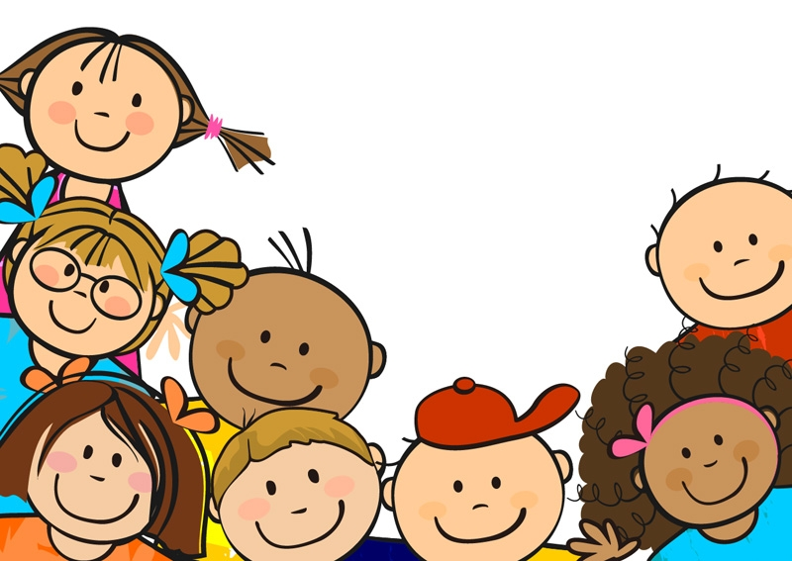

|  |
| --- |
| **There are four sections to this guide:**   1. **Key information: the facts you need to know (pages 3 and 4)**   Please make sure you read this so you’re up-to-date with the things we’re doing a bit differently.   1. **Staying safe: a happy and healthy and safe place to learn (pages 5 and 6)**   You can read more about some of the measures we’ve put in place to be a safe place to learn.  Do read page 6 – it’s especially important.   1. **Teaching and learning: how we’ll adapt our curriculum (pages 7 - 11)**   Many of you will be interested to find out more about the changes to how we teach and what we teach.   1. **Covid-19 safeguarding priorities (pages 12 and 13)**   This part acts as our policy for various things, including behaviour and social distancing. |

**Things in this guide are subject to change as the government updates guidance and as we evaluate how things go, ready to iron out any glitches as we go along.**

**Our priorities**

Our ultimate priority is to continue to be a happy and healthy **and safe** place to learn. To do this, we’ve nine key principles at the forefront of our plans:

1. Minimise contact with individuals who are unwell by ensuring that someone who has Covid-19 symptoms, or who has someone in their household with symptoms, doesn’t come to school
2. Clean hands thoroughly and more often than usual
3. Ensure good respiratory hygiene by promoting the ‘catch it, bin it, kill it’ approach
4. Enhanced cleaning, including lots of cleaning of frequently touched surfaces
5. Minimise contact between individuals and maintain social distancing where possible
6. Where necessary, wear appropriate personal protective equipment (PPE) (including face shields)
7. Engage with the NHS Test and Trace process
8. Manage confirmed cases of coronavirus (Covid-19) amongst the school community
9. Contain any outbreak by following local Public Health England advice

Read more about these priorities in our section, Staying Safe (page 5).

Linked to this, and just as important, is the wellbeing of our pupils. During the school closure, we know that children may have had very different experiences in terms of family life (for example, they may have experienced bereavement) and in terms of learning (for example, some will have been able to access the home learning enthusiastically, and others less so). As a result, we know that we’ll need to adapt what we do in school for a while.

Read more about this in our Teaching and Learning section (page 7).

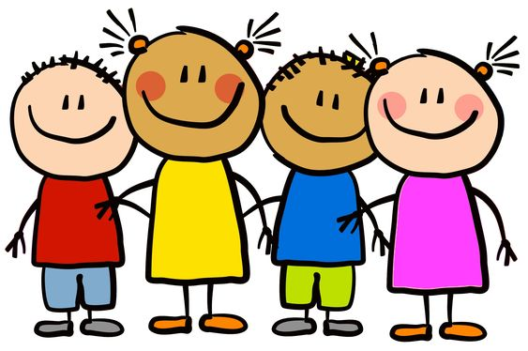

Much of what is set out in this document stems from:

* Guidance for full opening: schools (Department for Education, 02 July 2020)
* Leeds City Council Schools Health, Safety & Wellbeing Team guidance

**Key information:**

**the facts you need to know**

**Start and end of the school day**

We need a way to make sure all our children can get in and out of school safely. As we ease out of lockdown, it’s still important to reduce ‘people traffic’ around school at these busy times.

**Staggered start and end times**

Doing this allows us to maximise learning time – something which the guidance from the Department for Education prioritises.

|  |  |  |
| --- | --- | --- |
|  | **Morning** | **Afternoon** |
| **Foundation 1 (F1)** | 9.00am | 3.00pm |
| **Foundation 2 (F2)** | 8.45am | 3.00pm |
| *Foundation 1 and 2 parents will have received their child’s individual transition plan and will follow this until their child is attending full day sessions (Foundation2) or their requested sessions (Foundation 1).*  *Please contact the school office if you’ve any questions.* | | |
| **Year 1/2** | 8.50am | 3.00pm |
| **Year 3/4** | 9.00am | 3.15pm |
| **Year 5/6** | 9.00am | 3.15pm |

Where you have children in different classes, please bring all children at the earliest time and pick up at the earliest time*. For example, a family with a child in Y1 and Y4 would bring all children at 08.50 and pick all children up at 15.00.  Siblings will be in the playground with an adult ready to be collected.*

Lunchtimes will be shortened by 10 minutes, so learning time isn't affected.

**Entering and leaving school**

Because we’re a small school, we don’t need to introduce complicated procedures using different entrances and exits. The entrance will be the main gate as normal.

**Other things you can do to help**

* Please be punctual. This will help us to keep our community safe by reducing congestion.
* If you’re waiting in the playground, please ensure your child stands with you and doesn’t mix with other children who may be in a different bubble. Children mixing across bubbles undermines our risk assessment.
* Where possible, just one adult should drop-off and pick-up. This reduces the number of adults on site.
* Whilst our playground has always had a community feel about it with people enjoying chatting in groups and catching up with others, during this time, please leave the school site immediately after dropping off or picking up.
* Avoid congregating in the playground and always keep at least 1m from other families.
* Avoid coming into the school building where necessary; if you need to visit the office, only enter if there’s nobody waiting.

**School uniform**

Children should wear their usual school uniform.

**On the days your child has PE, they should come to school in their PE kit.** (Track-suit bottoms instead of shorts would be good on colder days.)

Read about our uniform policy: <https://www.stjameswetherby.leeds.sch.uk/find-out/policies/>

**Lunch and refreshments**

If your child has a school dinner, it’ll be a warm or cold packed lunch type meal for at least the first few weeks of the Autumn term. Other children should bring a packed lunch.

If your child has milk, this will still be provided.

Your child must bring water in their own water bottle, taken home each day.

Your child might want to bring some fruit for a mid-morning snack.

**Out of school club**

**and other provision after school**

**Out of school club**

The before and after school club will start on Monday 07 September. **Before-school club starts at the new earlier time of 7.30am.** After-school club finishes at the usual time of 6.00pm.

If you’d like your child to attend, please inform the school office.

**After-school clubs**

For the time being, there won’t be any after-school clubs.

**External providers**

If you use external providers for childcare, or your child attends clubs after school, government guidance is that it might help to stop the spread of the coronavirus if you limit these in a reasonable way:

*‘It is for this reason that parents and carers are being encouraged to limit the number of settings their children attend as far as possible, and ideally to ensure their children attend the same setting consistently.’*

Protective measures for out-of-school settings during the coronavirus (COVID-19) outbreak (Department for Education, 10 July 2020)

**Things to bring to school**

We’re limiting the number of things that children bring in to school. Your child should bring only:

* a small school bag
* a filled water bottle – ideally big enough to last the day
* jacket
* lunch box (if they’re not having a school dinner)
* fruit
* hand cream (optional, but this could be really useful)
* sun hat when appropriate

In warm weather, we’d prefer all-day sun cream to be applied before school. If this is a problem, children can bring sun cream that can then be left at school.

Children should wear their PE kits on their days for PE.

Children will take home only their own belongings. We’ll make a decision early in Autumn term for guidance on whether books are going home.

Your child’s Homework book will be sent home at the start of the term and should stay at home for the first few weeks at least (see p11 for more information).

**Staying safe:**

**a happy and healthy**

**and safe place to learn**

**Our priorities**

Our ultimate priority is to continue to be a happy and healthy

**and safe** place to learn. To do this, we’ve had nine key principles at the forefront of our plans – you can see these on page 2.

Leeds City Council’s risk assessment is a comprehensive checklist of things for

school leaders to consider. There are 36 sections in total, covering 282 points.

This covers the obvious things such as cleaning and pupil wellbeing, but there are

other things to consider too, like contractors visiting the site, deciding what resources can

be shared safely, and working alongside our catering agency.

**We’re confident that we’ve considered everything closely and carefully, making our school as safe as it possibly can be.**

**Minimising contact and mixing**

Children will be placed in classes which will operate as much as possible as a large ‘bubble’. Sometimes, the bubble will mix with some others, but we’ll only do this if it’s really useful in terms of teaching and learning.

Children and adults from one bubble will not often mix with those from another. If / when they do, it will be to maximise good teaching and learning opportunities. The mix will be limited to a larger bubble, such as a phase group.

The adults who work in the class will nearly always be the same. When the adult is different, we’ll have a record of any other bubble they’ve worked in so we can operate our own tracing, a bit like the NHS ‘Test and Trace’ system.

**Frequent hand washing / sanitising**

Children will be expected to wash or sanitise their hands frequently, including on arrival at school; before and after playtimes and lunch times; and after using tissues. Your child can bring hand cream to school to combat dryness.

**Catch it, bin it, kill it**

For a long time now, we’ve encouraged children to use the ‘vampire method’ if they cough or sneeze. For years, one of our weekly Living and Learning statements has been ‘I cover my mouth when I cough, sneeze or yawn’. This means our children should be in good position to go one step further with their hygiene by using a disposable tissue and binning it straight away. (And by the way, we’ve ordered plenty of boxes of tissues.)

**Cleaning**

Schools aren’t being provided with extra funds to pay for enhanced cleaning, but we know this is important to you.

We’ve put in place extra cleaning of communal areas, like high touch surfaces of the entrance area, corridors and toilets. This will mean high-touch areas are sanitized even more frequently than before.

This is in addition to arrangements already in place for cleaning high-touch areas of the classrooms, like door and tap handles. High-touch surfaces such as door handles, taps and commonly used surfaces will be cleaned frequently throughout the day – each time children take a break outside, for example.

In addition, we’ve bought sanitising fogging machine, which will sanitise the whole room, including carpets.

**Do we have up-to-date contact details for you?**

**Do we have up-to-date medical information about your child?**

**Suspected and confirmed cases of Covid-19**

**Please be really vigilant for the**

**symptoms of Covid-19:**

**What if your child has symptoms of Covid-19?**

|  |
| --- |
| **At home**, if your child displays symptoms of Covid-19, please don’t send them to school.  Keep them at home to self-isolate for ten days and order a test. The rest of the household should self-isolate for 14 days.  Tell school so we can alert others if we need to.  **At school**, if your child displays symptoms, we’ll contact you to collect your child as a matter of urgency. Please make sure there’s someone from your household who can do this.  We’ll encourage you to have your child tested. Go online to book the test: <https://www.gov.uk/get-coronavirus-test>  Alternatively, contact NHS 111 for medical advice. (For children under 5, call 111.)  If your child tests negative, they may return to school and other household members can end their self-isolation.  If your child tests positive for having Covid-19, they should complete the remainder of the ten day self-isolation and all others in the household should complete the 14 day self-isolation.  **Please tell us the results of the test as soon as you can.**  You must also share information promptly about recent contacts through the NHS Test and Trace service to help alert other people who may need to self-isolate. |

**What if someone else in the household has symptoms of Covid-19?**

|  |
| --- |
| Please don’t send your child to school if someone in the household has symptoms. Tell school so we can alert others if we need to. |

**Further guidance is available:** [**h**[**ttps://www.nhs.uk/conditions/coronavirus-covid-19/**](https://www.nhs.uk/conditions/coronavirus-covid-19/)](https://www.gov.uk/government/publications/covid-19-stay-at-home-guidance)

**What happens at school if there’s a case of Covid-19?**

|  |
| --- |
| If a case is confirmed, school will contact Public Health England for advice around which bubble(s) should be collapsed and which staff and pupils should be sent home to self-isolate for 14 days.  (The rest of the household doesn’t need to do this unless they subsequently develop symptoms.)  The bubble’s room will be deep-cleaned. |

This is constantly changing situation. The information here is all subject to change.

**Make sure we’re fully up to date with your contact details and your child’s medical information.**

**Teaching and learning:**

**how we’ve adapted our curriculum**

**Overview**

We’ve made changes to the timetable to allow for staggered playtimes and lunchtimes.

|  |
| --- |
| We’ve made changes to the curriculum, too. The two key principles are:   * **a broad and balanced curriculum** * **a flexible curriculum**   Flexibility is important. It allows teachers a chance to adapt things to meet the needs of the children, in terms of both   * **wellbeing**: there’s a focus on emotional wellbeing and Living and Learning skills * **learning**: teaching and learning goals, which prioritise closing any gaps in learning that might have arisen, especially in Reading, Writing and Maths |

**Reading, Writing and Maths**

While maintaining a broad and balanced curriculum, we’re focus on making sure all children are secure in some essential knowledge and skills in Reading, Writing and Maths that they need to support future learning. Every individual has had a different experience of learning at home and so teachers are taking care to understand any gaps that classes or individuals have, and adapt their teaching to address these.

We’re initially dedicating additional time to secure the most important aspects of each subject. The balance of these aspects of learning are constantly under review to maximise learning for every individual.

**Reading**

* phonics – we’re supporting children’s understanding through additional phonics sessions for children in Y1 to Y4, as well as targeted time for individuals with specific gaps in learning.
* fluency – all children in Y1-Y4 have time dedicated to developing reading fluency; children in Y5 and Y6 are also developing reading fluency by reading with adults and as a whole class.
* information retrieval, interpreting meaning and understanding language choices – these three vital reading skills, which are already embedded within our curriculum, have a greater focus in September.

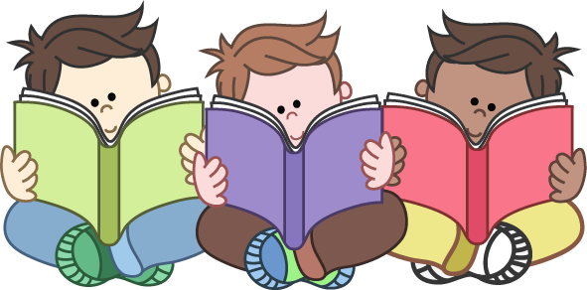

**Writing**

We’re concentrating on teaching children the key essentials of grammar and punctuation, recapping on prior learning to make sure it’s secure before moving on. We’re focusing on sentences and short pieces of writing to build up the secure understanding, stamina and resilience needed for longer and more independent pieces later on in the year.

**Maths**

Children are being taught the key essential concepts for their year group, recapping on prior learning to ensure they have the foundations they need to make good progress. Fluency, reasoning and problem solving are embedded within these essential concepts:

* number and place value
* number facts
* addition and subtraction
* multiplication and division

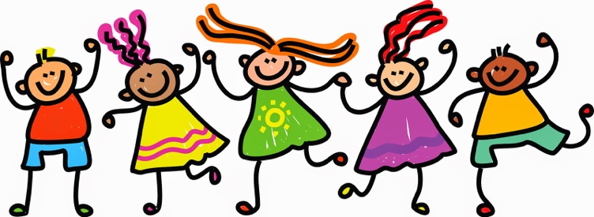**Wellbeing – Living and learning**

Living and Learning is the name for all the teaching and learning we do around Personal, Social, Health and Economic Education (PSHE). This is the ideal subject to support your child’s wellbeing as they return to school, or welcome others back to school. Our children have had many different experiences during lockdown and over the summer and we’re committed to supporting them back into school life.

One of the ways we’re doing this is to make sure our curriculum is flexible, so we can meet the needs of the children. Especially at first, many of the activities are designed to be enriching and engaging, so we can enthuse children again: we want our school to be a happy and healthy place to learn. On top of this, the Living and Learning sessions in each class support children.

Each week in school, there’s a Living and Learning statement. The first few we’ve planned help to support your child to settle back into school.

* I can show friendship.
* I know the 8 Rs for learning.
* I use the 8 Rs to help me learn.
* I listen to, share with and include others.
* I recognise that friends and family are important.
* I know how to be a good friend.

**Our picture book topics**

We’ve selected a picture book as a whole school topic for the first three weeks:

**After the Fall (How Humpty Dumpty Got Back Up Again)** by Dan Santat.

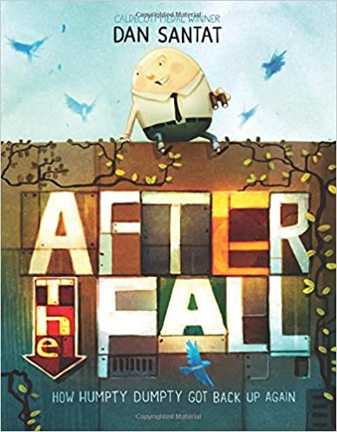

We’ve decided on an initial whole-school text so that it helps to bring our

school community back together in a shared theme. That doesn’t mean

children will all learn the same things – teachers pitch the learning in an

age-appropriate way.

Picture books aren’t just for pre-school children. We’ve chosen a picture

book as a whole school short topic for lots of reasons, including:

* they’re often accessible by many age ranges, so perfect as a

whole-school text, helping to bring our school community

together in a shared theme

* they’re very engaging – perfect to help people get stuck into

school life again

* they’re short, so can be read in their entirety, and then re-read

and explored in lots of different ways

* they allow teachers to be flexible in their approach, so teachers

can focus on different aspects of the story and meet children’s

needs and interests – and get creative!

And we think this particular picture book is a good choice:

Humpty Dumpty gets back up again after a fall – this could be a good

analogy with recent events. As the blurb says:

‘*After the Fall (How Humpty Dumpty Got Back Up Again)* is a

masterful picture book that will remind readers of all ages that *life begins when you get back up*.’ – that’s what we need to start doing after lockdown.

After three weeks with this book as a theme, teachers will select another picture book of their own for a similar short topic.

**Our revised curriculum**

You can read about our full curriculum on our website – *Our curriculum and expectations page*:

<https://www.stjameswetherby.leeds.sch.uk/learn-more/other-subjects/>

Much of what is published on our website is still relevant in the Autumn, but we’ve made some tweaks so that the curriculum meets the two key principles (to be a broad and balanced curriculum, and to be flexible).

A main difference is that we’ve changed the Autumn topics. This is our curriculum plan for the Autumn term 2020-21:

|  |  |  |  |  |  |
| --- | --- | --- | --- | --- | --- |
|  | **Year 1 and 2** | | **Year 3 and 4** | | **Year 5 and 6** |
| **Autumn**  **1** | **Whole school picture books**:  *After the Fall (How Humpty Dumpty Got Back Up Again)* by Dan Santat  weeks 1, 2, 3  Another picture book selected by teachers  weeks 4, 5 and possibly 6  In the remaining weeks of Autumn 1 (possibly week 6, and definitely week 7), teachers will introduce a book that features on the regular Reading long-term plan. This will continue to be the Reading theme throughout Autumn 2.  The texts are likely to be chosen from the following (although teachers do always have flexibility to choose alternative texts to suit their children’s interests). | | | | |
| *Toby and The Great Fire of London*  by Margaret Nash  *The Great Fire of London*  by Liz Gogerly  *Vlad and the Great Fire of London*  by Kate Cunningham | *Greek Myths*  by Marcia Williams  *Who Let the Gods Out?*  by Maz Evans  *Give Peas a Chance*  by Morris Gleitzman (short stories) | | *The Boy with the Bronze Axe* by Kathleen Fidler  *Wolf Brother*  by Michelle Paver | |
| **Autumn**  **2** | **History**:  Great Fire of London  (events beyond living memory;  with reference to local history) | | **History**:  Ancient Greece | | **History**:  Stone Age to  Iron Age  Ancient Egypt |
| Our regular curriculum features an extensive list of skills and knowledge to be learnt each half-term in each topic. We’ve identified some key History learning (see below) so that in Autumn 2, the curriculum continues to be flexible, broad and balanced. | | | | |

The curriculum for the Spring term and beyond will be reviewed.



Our History curriculum for the Autumn 2020-21 term normally features 10-14 learning objectives. This is a lot in a term when we want the curriculum to be flexible and to be broad and balanced, so we’ve highlighted in bold text below the objectives that we want teachers to concentrate on – so, basically, we have a series of learning which is ‘should do’ (in bold) or ‘could do’ (the rest).

|  |  |  |
| --- | --- | --- |
| **Y1 and Y2** (expectations for the end of Y2) | **Y3 and Y4** (expectations for the end of Y4) | **Y5 and Y6** (expectations for the end of Y6) |
| **The Great Fire of London** | **Ancient Greece** | **Stone Age to Iron Age contrasted with**  **Ancient Egypt** |
| **Knowledge and other learning** | **Knowledge and other learning** | **Knowledge and other learning** |
| * I know and can use words and phrases relating to time and chronology (eg old, new, past, a very long time ago, present, ancient, modern). * I know what houses were like before the Great Fire of London and that fires were quite common. * **I know that Samuel Pepys’ diary helps us to know what the Great Fire of London was like.** * **I know why the fire spread quickly and how it was eventually put out.** * **I know what changed as a consequence of the Great Fire of London.** | * I know that ancient Greece was divided into many city states and I know that Athens and Sparta were the most powerful. I know some of the main characteristics of the Athenians and the Spartans. * **I know about the influence the gods had on Ancient Greece.** * **I know about the influence Ancient Greece has had on the Western world, eg philosophy, arts, science, maths, literature and politics.** * **I know that democracy is a Greek word meaning ‘government by the people’ and that our government today is a legacy of the Athenian assembly and council.** | * **I know how Britain changed between the beginning of the stone age and the iron age.** * **I know the main differences between the Stone, Bronze and Iron ages.** * I know what is meant by ‘hunter-gatherer’. * **I know about and can name some of the advanced societies that were in the world around 3000 years ago.** * **I can compare life in Britain 3000 years ago to life in Ancient Egypt.** * I know that the ancient Egyptians had a writing system called hieroglyphics. * I know that the ancient Egyptians built pyramids as tombs for pharaohs and that the biggest was built around 2500BC. |
| **Skills** | **Skills** | **Skills** |
| **Time and chronology**   * **I can sequence events (eg within my own life time) and objects (eg Victorian, 1970s and modern toys) in chronological order and give plausible reasons for this order.**   **Change and continuity**   * I can recognise similarities and differences between my life and the life of an older person (eg holidays, toys, transport).   **Cause and effect**   * **I can explain how significant people and events have changed our way of life (eg why the Great Fire of London happened).**   **Historical sources**   * I can ask and answer questions about the past using different historical sources (eg photographs, written records, people).   **Historical interpretation**   * I can use my historical imagination to make inferences about people’s lives and their feelings (eg how Mary Seacole felt when tending injured soldiers). | **Time and chronology**   * **I can sequence key periods and events in chronological order using historical knowledge and / or enquiry skills and a growing awareness of dates.**   **Change and continuity**   * I can recognise similarities and differences between the lives of people living in different periods of time.   **Cause and effect**   * **I can explain why significant events happened, why people behaved as they did, and begin to think about the consequences this may have had (eg why the Romans invaded Britain and what this meant for British people).**   **Historical sources**   * I can ask and answer questions about the past using primary and secondary sources to gain a clearer understanding. * I can begin to evaluate historical sources with an awareness that recent history has a greater number of sources.   **Historical interpretation**   * I understand that people may have different interpretations of the past (eg Howard Carter: tomb raider or celebrated archaeologist?) and that there may be different points of view in primary and secondary sources. | **Time and chronology**   * **I can sequence key periods of British and world history in chronological order using dates.** * I can use a timeline to give information about a period of history (eg plot key developments across a period of local history) or a theme (eg plot key developments of a theme, like transport, across periods of history).   **Change and continuity**   * **I can recognise and offer plausible explanations for similarities and differences between the lives of people living in different periods of time and also between people living during the same period of time but in different places (eg comparing Viking Britain to the Early Islamic Civilisation).**   **Cause and effect**   * I can explain why significant events happened and why people behaved as they did, and can understand the consequences, including those for the present day (eg conflicts, inventions and other advances).   **Historical sources**   * I can evaluate historical sources based on reliability and bias. * I can ask and answer questions by selecting from a range of sources (both primary and secondary) to gain a clearer understanding.   **Historical interpretation**   * **I can debate different interpretations of people and events and demonstrate an appropriate understanding of different points of view.** |

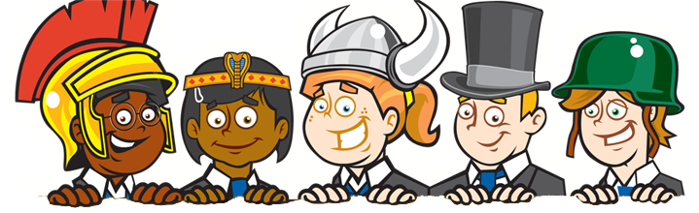

**Other subjects**

For Autumn 1, there are no swimming sessions for our children.

There are no individual instrument tuition sessions, either.

We’ll keep reviewing this.

**Homework**

We’re setting weekly homework as we normally do. **The key difference here is that Homework Books should stay at home for the time being.**

Just as normal, the tasks are posted on the website. Instead of the task pasted into books, children take home a piece of paper with the task on, too. The tasks are a variety of Talk Time, Practice Makes Perfect and Creative, but especially the first two.

Parents can email a picture or update about a completed task (just as many have been doing with the home learning tasks we set in Spring and Summer terms). The homework will be reviewed in school, so some pictures would be good!

**Contingency planning: home learning**

The guidance from the Department for Education (Guidance for full opening: schools) says:

*‘Remote education may need to be an essential component in the delivery of the school curriculum for some pupils, alongside classroom teaching, or in the case of a local lockdown. All schools are therefore expected to plan to ensure any pupils educated at home for some of the time are given the support they need to master the curriculum and so make good progress.’*

**So far, we’ve done this…**

Three daily home learning activities for the many children who remained at home, and teachers were available by email to respond to the home learning.

We enhanced this provision by including pre-recorded video lessons, which had three main benefits:

* they enabled teachers to model and explain concepts
* they engaged and motivated children
* they provided a valuable connection between home and school

The feedback from parents in the 2020 annual survey has been very positive:

|  |  |  |
| --- | --- | --- |
| **Moortown Primary:**  *‘The home-schooling material provided has allowed us to manage all our commitments. It has given my daughter structure with enough resources and flexibility to enjoyably complete her task.’* | **Scholes (Elmet) Primary:**  *‘During the coronavirus situation, the support has been excellent. The daily work being set and variety of tasks has been fabulous. Thank you for the fabulous work that you do.’* | **St James' CE Primary:**  *‘During lockdown, I have worked more than ever…and as a single parent family... The work from school is a real blessing and is sufficiently appealing that she does it (and wants to do it) on her own.’* |

**We’re planning to enhance the provision**

**in the event of a bubble lockdown, school closure or local lockdown…**

These are some of the things we’re exploring:

* the number of daily video lessons, including the government-approved lessons from Oak Academy and BBC
* face-to-face or telephone contact time with pupils over platforms like Zoom (now that Zoom’s security is stronger); the focus of this contact time will be on pupil wellbeing
* alternatives to online learning

|  |  |
| --- | --- |
| **../../../../../Desktop/Sphere%20Federation%20Logo%20Suite/Sphere%20Logo%20Full%20Colour/Landscape/Sphere%20Federation_landscape_full%20c** | **Scholes (Elmet) Primary**  **St James’ CE Primary**  **Moortown Primary** |
| **Autumn for all pupils:**  **Covid-19 safeguarding priorities** | |
| **Date:** 29 May 2020; updated 05.06.20, 02.07.20, 15.07.20 in preparation for full opening of schools in Autumn | |

|  |
| --- |
| School leaders have prepared an extensive risk assessment to make sure that our children and staff stay safe in school. Without our school community (pupils, parents / carers and staff) all adhering to the current government guidance on social distancing, the measures we take in school will be undermined.  This policy outlines how children and staff can stay safe at school by adhering to all aspects of staying safe in the context of coronavirus, such as handwashing and being alert to Covid-19 symptoms.  Although the following refers to ‘child’ and ‘parent / carer’, the content applies equally to staff members.  The policy has been produced following assessment of the risks surrounding coronavirus, many of which are set out in Leeds City Council’s risk assessment template. |

**Social distancing**

The government’s message about social contact is subject to reviews and updates. We follow the current guidelines in school and expect families to do so out of school. The latest guidance is here:

<https://www.gov.uk/government/publications/staying-alert-and-safe-social-distancing/staying-alert-and-safe-social-distancing-after-4-july>

From 13 June, a single adult household has been able to ‘bubble up’ with a larger household to form a ‘support bubble’, provided that the two form a group together and not mix with others beyond that.

<https://www.gov.uk/guidance/meeting-people-from-outside-your-household-from-4-july>

**Indoors or outdoors**, from 04 July in England, you can meet in groups of up to two households (your support bubble counts as one household) in any location. You do not always have to meet with the same household - you can meet with different households at different times. However, it remains the case - even inside someone’s home - that **you should socially distance from anyone not in your own household**.

**Outdoors**, you can meet in groups of up to six people from different households as long as you remain at least one metre away (ideally two metres). This means that parents and carers should ensure their child stays at a distance from other people.

If a child says something that indicates they or someone in their household has not followed government guidelines (and therefore increasing the risk of spreading Covid-19), we’ll do some or all of the following:

* continue a conversation with the child in an **informal**, **friendly** way – this will help us to gain a better understanding and (hopefully) reassure ourselves that social distancing has not been undermined (there will be no leading questions)
* contact the child’s parents / carers to discuss what the child has said and to clarify the situation
* isolate the child away from the rest of the children in their ‘bubble’ while we wait for more clarification from the child or their parents / carers

Equally, if an adult says something that indicates another family may not have followed government guidelines, we’ll follow this up too.

**Other Covid-19 safeguarding priorities**

As well as social distancing, there are other Covid-19 safeguarding priorities. For example,

* handwashing (we have scheduled at least five times during the school day for this to happen)
* being alert to symptoms (high temperature; new, continuous cough; loss or change to sense of smell or taste) and making sure parents alert school if their child shows any of the symptoms

**Pupil behaviour**

Pupils’ behaviour in Sphere Federation schools is good. We will continue to follow our Positive Relationships Policy (see website or contact school to request a copy), making small, appropriate changes eg a pupil will not be sent to another classroom as part of a warning. The aims and positive and negative consequences set out in the policy remain important as more and more pupils return to school.

One of our school rules is ‘We follow instructions’. This rule will continue to be important; for example:

* following instructions about different routines for arrival or departure
* following instructions on hygiene, such as handwashing
* following instructions on who pupils can socialise with

Serious poor behaviour in Sphere Federation schools is rare, but our Positive Relationships Policy does make reference to it; an extract is shown here:

*‘Serious misbehaviour**(eg disrespect to staff, property or cultures, swearing, fighting) is unacceptable. Such behaviour would mean warnings are automatically by-passed to higher level warnings. We contact parents to keep them in the picture and to discuss ways to respond and gain a consistent message between home and school. A serious incident form…is typically completed in such cases.*

*The safety of the children is paramount in all situations. If a child’s behaviour endangers the safety of others, the class teacher stops the activity and prevents the child from taking part for the rest of that session.’*

The risk assessment that we have in place comes from Leeds City Council’s risk assessment template, which states: *‘The behaviour policy should include steps to be taken if pupils fail to follow the new rules and routines or deliberately put themselves or others at risk eg deliberately coughing or spitting on another person.’*

In the context of coronavirus, we would regard behaviour such as deliberate coughing or spitting as serious misbehaviour. For the safety of other pupils and our staff, we would therefore follow our Positive Relationships Policy: in particular, we would *‘contact parents to keep them in the picture and to discuss ways to respond’*. Actions taken by us following such an incident would reflect the priorities set out here in the context of safeguarding and protecting staff and pupils from Covid-19; these are set out below. This overrides what is in the Positive Relationships Policy.

**Actions we will take to follow the policy**

**Following all the points set out in this policy will all help to stop the spread of the virus. As such, we will follow this policy strictly and communicate it frequently and widely.**

In these very difficult times, we do need to prioritise staying safe for all our pupils, parents and staff. We will constantly review our risk assessment to ensure our policies and practices prioritise staying safe for all.

If we have concerns, we may have to ask a parent / carer to collect their child from school, possibly to self-isolate for 14 days or until they can provide evidence of a negative test result for Covid-19. This is because we have to be confident children can attend school in a way which does not undermine the safeguarding of others.

It is possible that we have to make a decision that we can't safely have a child at school due to concerns about social distancing. We would make that decision reluctantly, but the safeguarding of all pupils and staff must be our priority.

|  |
| --- |
| *‘The decision as to whether a child can be or continue to be offered a place at present in school will be based on [an Individual Pupil Risk Assessment / IPRA] and will lie with a headteacher. Writing specific control measures into an IPRA for parents and pupils to follow the current government guidance outside of the school setting is perfectly acceptable. If you then felt that the child’s / family’s behaviour outside school was breaching those control measures and creating a significant risk to staff and other children within school, it is appropriate to take reasonable steps to manage that risk, which could include delaying or removing the offer of a placement in school.’*  (Point 2, Health and Safety Bulletin 2020 no.22, Updates to the Coronavirus Risk Assessment 05.06.20) |